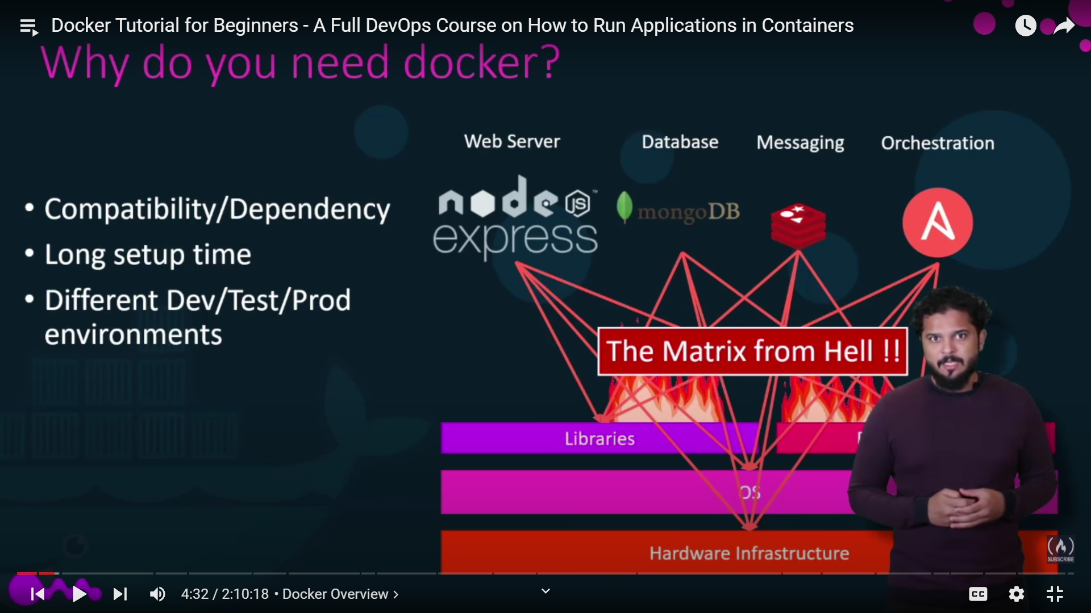

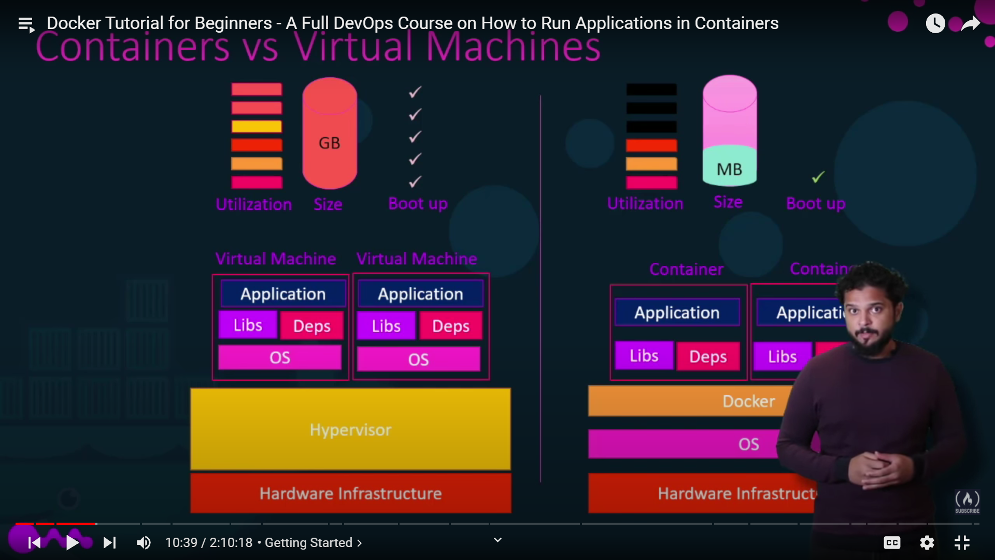

Docker run <image>

Docker ps -> what all the running container status

Docker ps –a 🡪 same + all stopped one

Docker stop <imagename> 🡪 to stop that image

Docker rm <imagenm> 🡪delete container

Docker rmi <imagenm> 🡪 delete all the container with the dependent container

Docker pull <image> 🡪 only pull the image not run

Container exists unless the process in side the container runs after that it deletes

Docker exec <image> cat /etc/hosts 🡪 to see the files in side the container

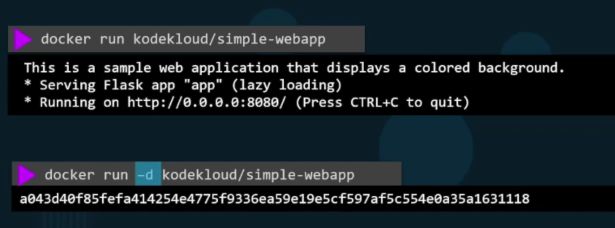

1st one will run the code and the screen will show the output but the second one will run the container in background

Docker image ls 🡪 to see all the docker images

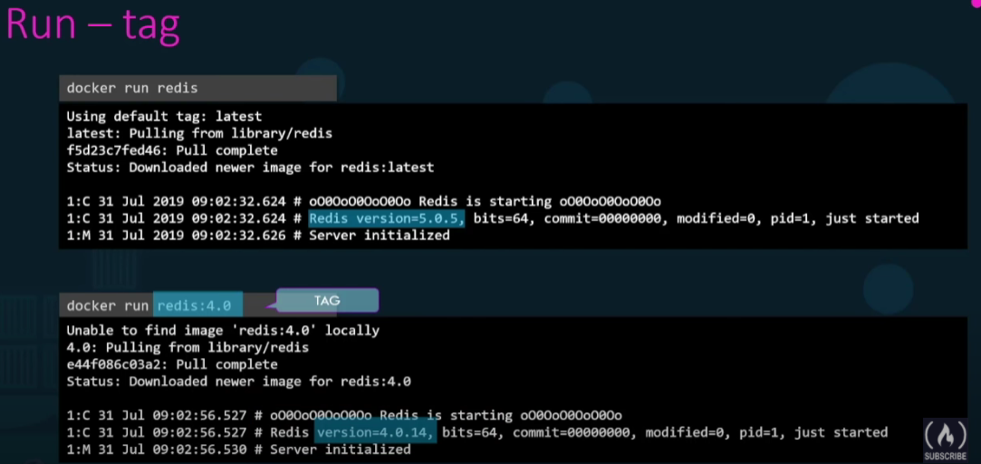

This is used to run specific version of the docker container

docker run -d --name webapp nginx:1.14-alpine 🡪 to run docker image in another name

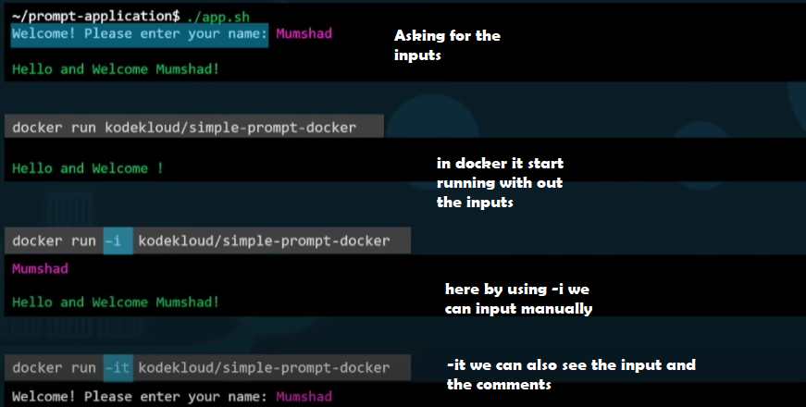

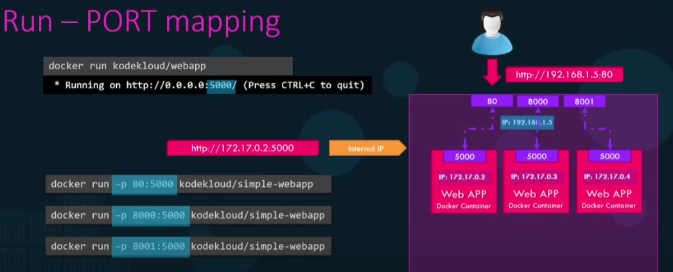

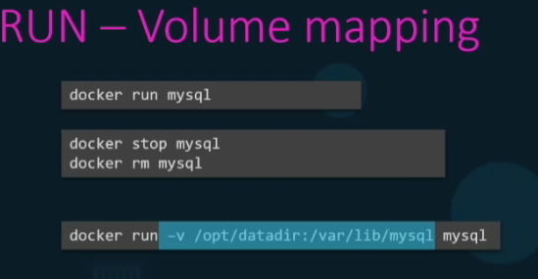

Docker inspect <docker image> 🡪 Docker inspect container

Docker logs <container id> 🡪 to check logs

Docker run –e <paramname = value> <dockerimage> 🡪 to set environment variable

CREATE AN IMAGE:

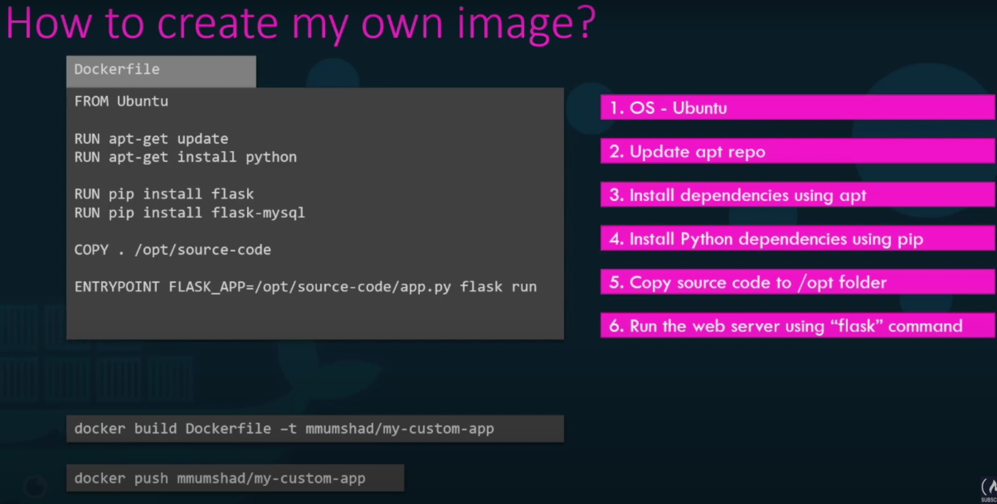

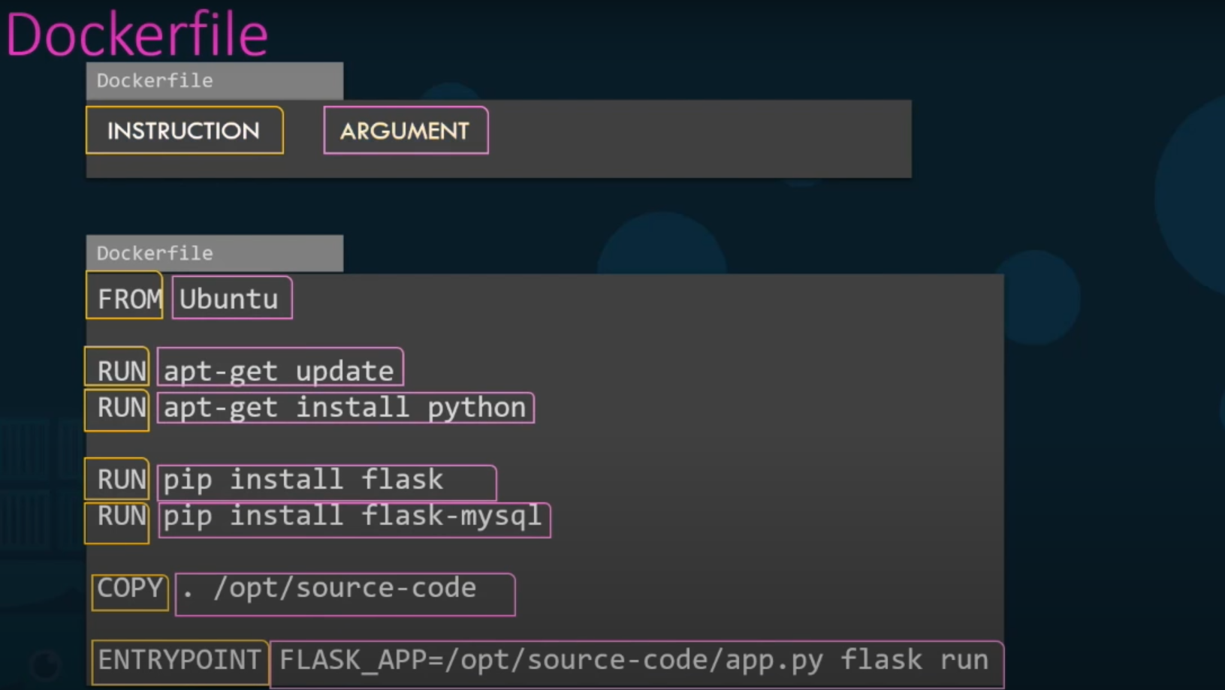

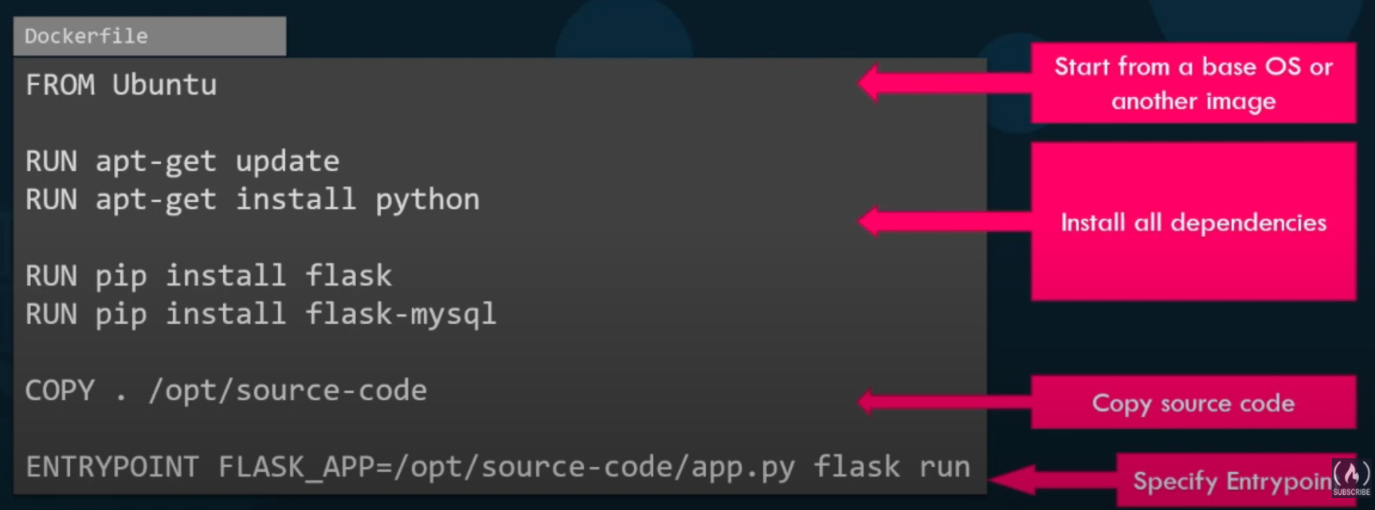

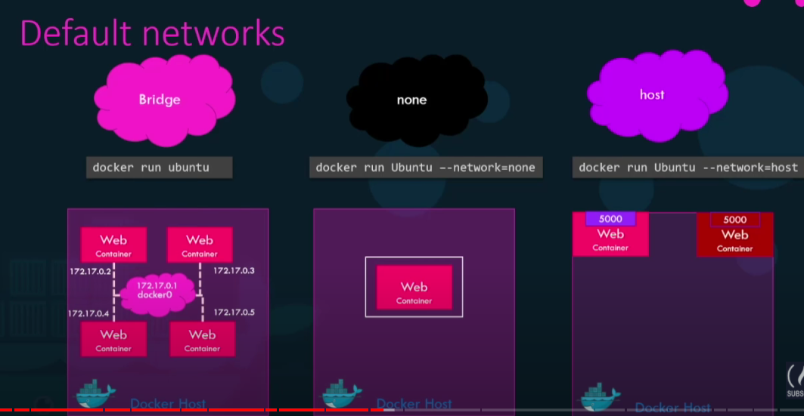

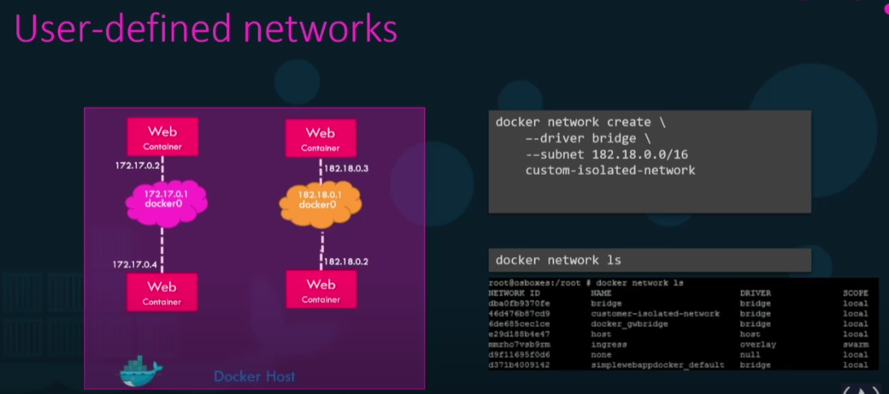

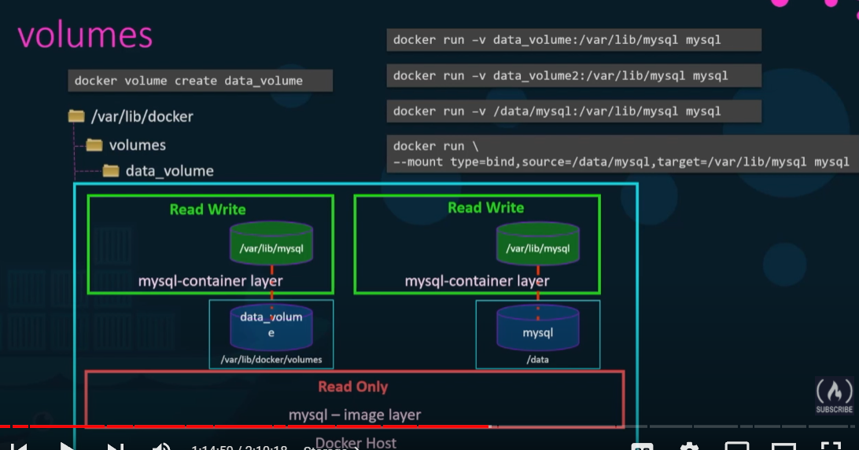

the above command is to mount and point the fileshare with it

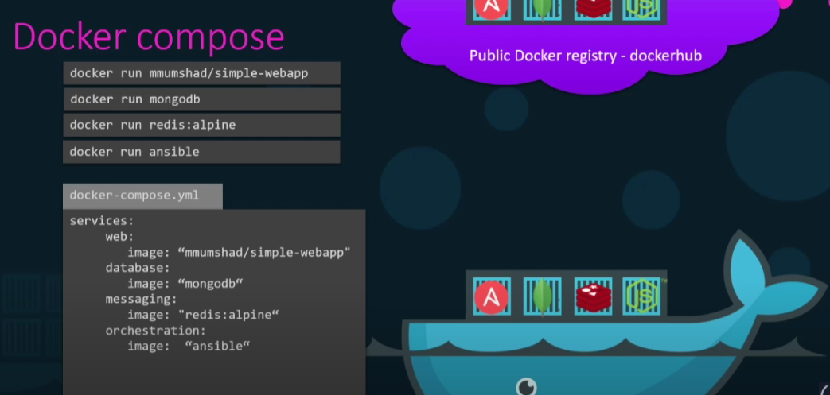

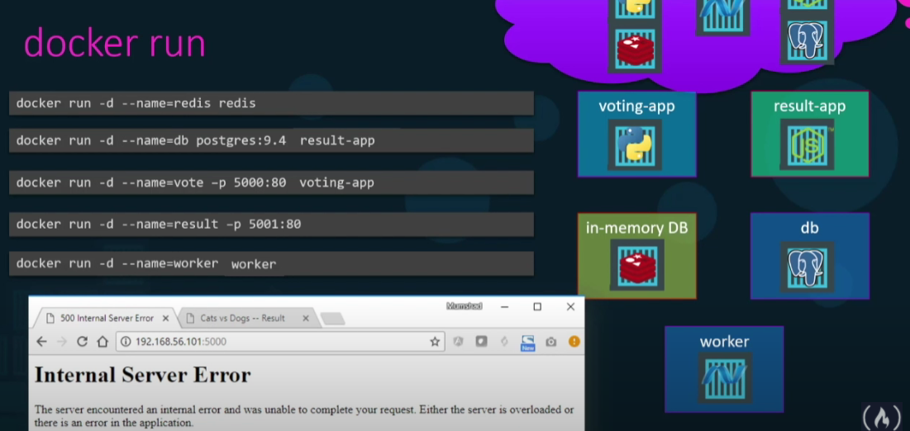we re name the services container and compose the image as per our need we linked the images

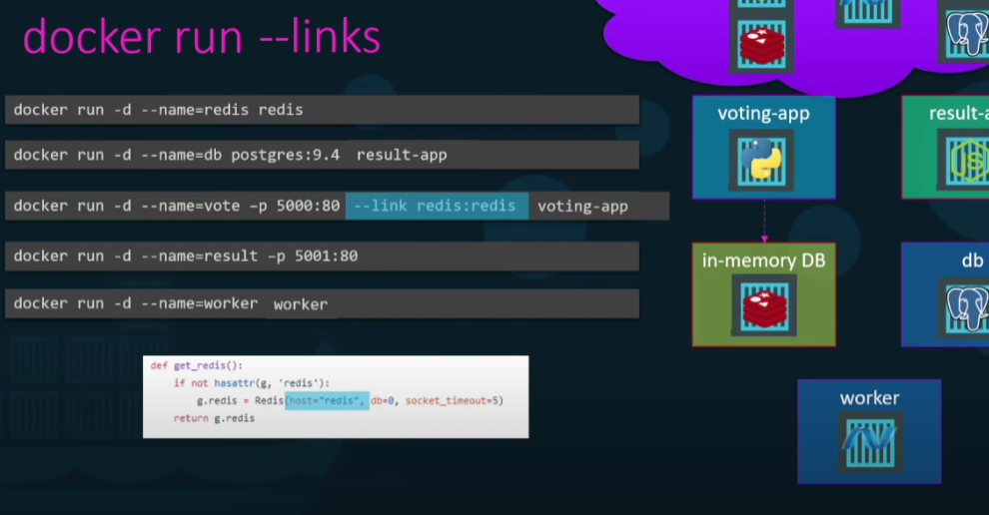

After linking all of them

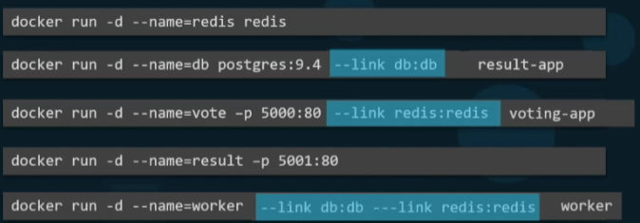

After the that we can compose the link

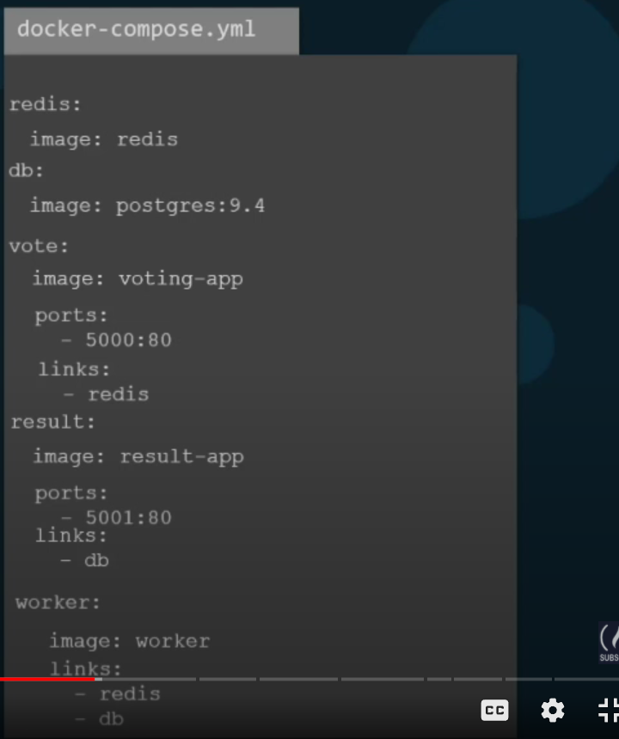

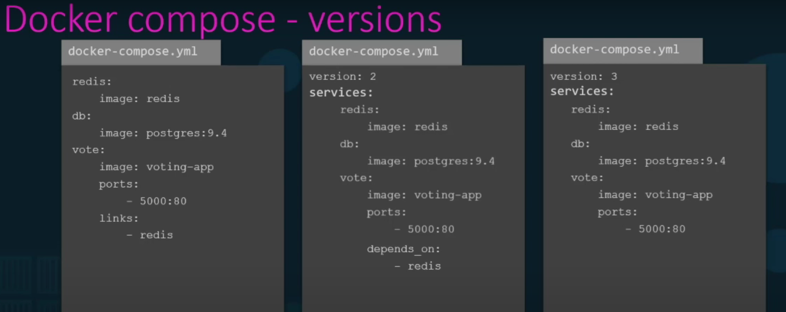

Docekr registry :

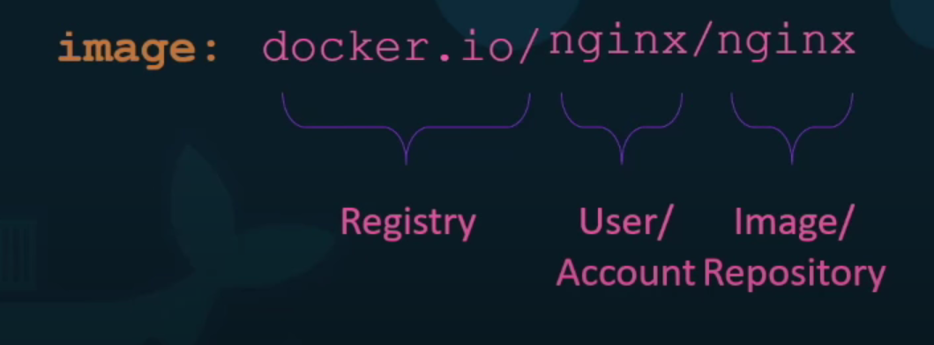

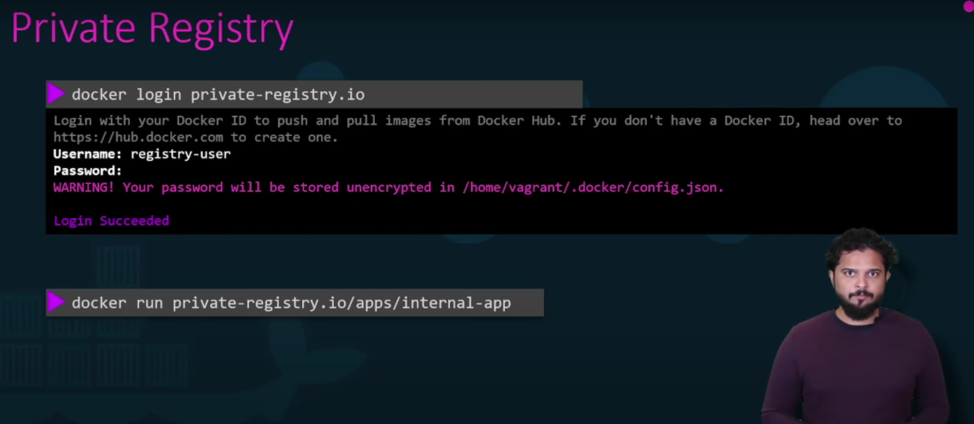 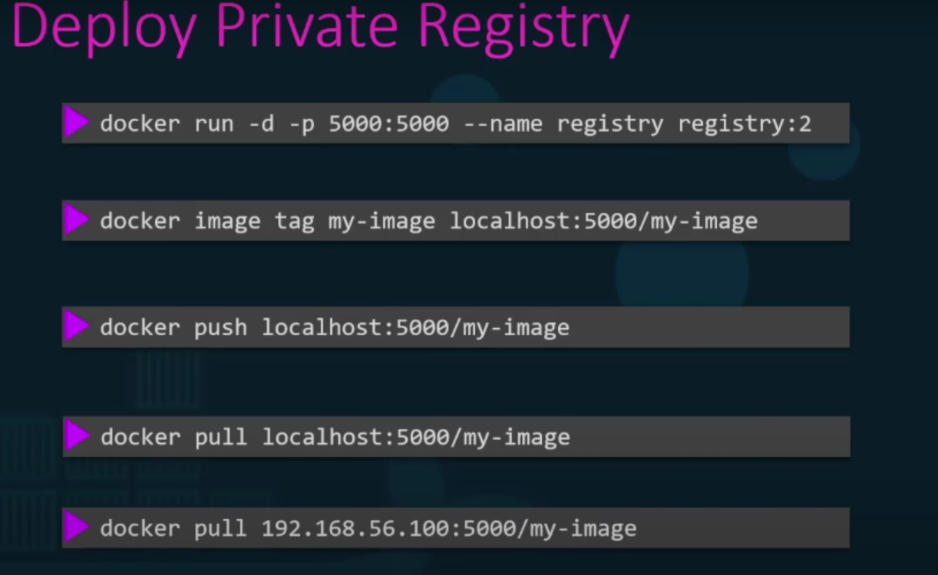

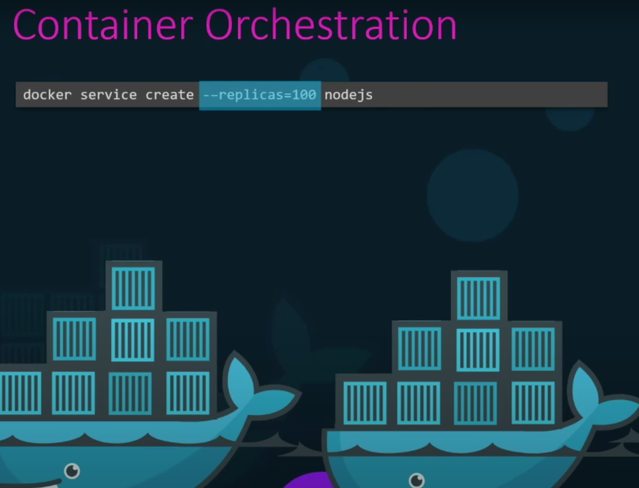this is used for the load balaencing of the application replicas will create 100 of instances

Docker swam will distribute the load with other containers

